**Hysterix**  **in Circuit Breaker**

Hystrix is a library that controls the interaction between microservices to provide latency and fault tolerance. Additionally, it makes sense to modify the UI to let the user know that something might not have worked as expected or would take more time. Implementing Fault Tolerance with Hystrix.

Netflix Hystrix, Resilince4j are two well-known circuit breakers which are used to handle such situations.

The circuit breaker pattern is a design pattern that falls under the sustainable design patterns category. It allows developers to prevent cascading failures in microservices architecture by invoking remote services through a proxy

**Why we are going for circuit Breaker?**

1. **Fault Tolerance**
2. **Prevent Cascading Failures**
3. **Resilience**
4. **Fallback Mechanism**
5. **Load Shedding**
6. **Health Monitoring**

**Fault Tolerance in Microservice:**

Fault Tolerance is the property that enables a system to continue operating properly in the event of the failure of some of its components.

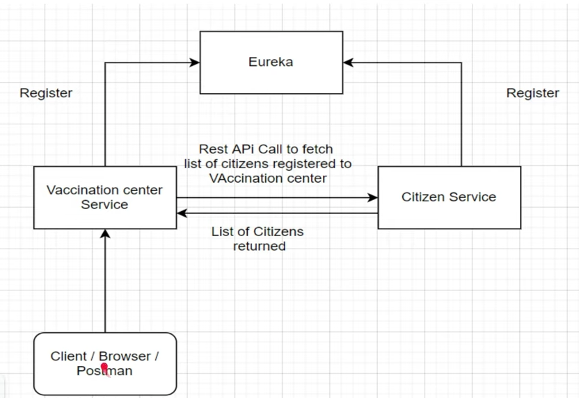

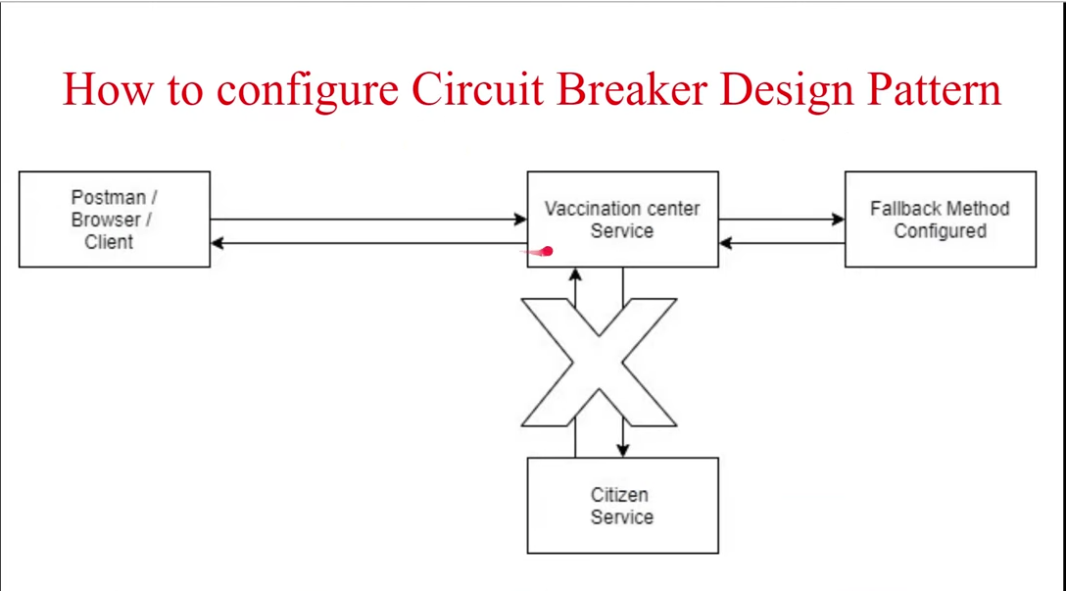

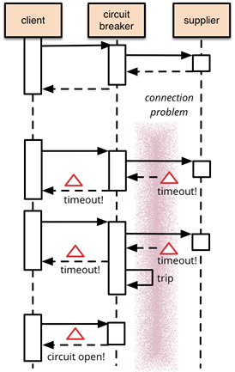

Trip->if a particular circuit will hit the api endpoint for many times it will break the circuit or the circuit will open finally so try to avoid that we use open way in circuit breaker will use the fallback method once facing any issue in the response side. At that time this fallback method will configure the data and will sent it as the response

**@Hystrix Command Elements:**

1.fallbackmethod:specifies a method to process fallback logic

2.threadpoolkey:The thread-pool key is used to represent a HystrixThreadPool for monitoring metrics publishing,caching and other such uses.

3. threadPoolProperties: specifies thread pool properties

4.groupkey:The command group key is used for grouping together commands such as for reporting,alerting,dashboards or team/library ownership

**Caching**: In micro-services architecture, caching can be an effective technique to improve the performance and scalability of services. Caching involves storing frequently accessed data in memory, so that it can be quickly retrieved and reused without the need to repeatedly query the underlying data source.

**Command properties :**specifies command properties like

1.circuitBreaker.requestVolume Threshold:number of requests reties before which circuit breaks

2.circuit Breaker.errorThresholdPercentage eg 60%:If 60%request fails out of total requests made then open the circuit

3.timeout:Its like wait for milliseconds and if no response,break circuit

The circuit breaker has three states:1.open 2.close 3.halfopen

## Closed State:

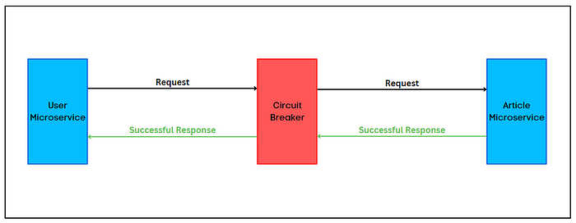

The initial state of the circuit breaker or the proxy is **the Closed** state. The circuit breaker allows microservices to communicate as usual and monitor the number of failures occurring within the defined time period. If the failure count exceeds the specified threshold value, the circuit breaker will move to the **Open** state. If not, it will reset the failure count and timeout period.

## 2. Open State

## https://miro.medium.com/v2/resize:fit:700/0*3Q2dgprx4udlrey8.png

Once the circuit breaker moves to the **Open** state, it will completely block the communication between microservices. So, the article service will not receive any requests, and the user service will receive an error from the circuit breaker.

The circuit breaker will remain in the **Open** state until the timeout period ends. Then, it will move into the **Half-Open** state.

## 3. Half-Open State

## https://miro.medium.com/v2/resize:fit:700/0*YAJPM2f2KqL2FbFH.png

In the **Half-Open** state, the circuit breaker will allow a limited number of requests to reach article service. If those requests are successful, the circuit breaker will switch the state to **Closed** and allow normal operations. If not, it will again block the requests for the defined timeout period.

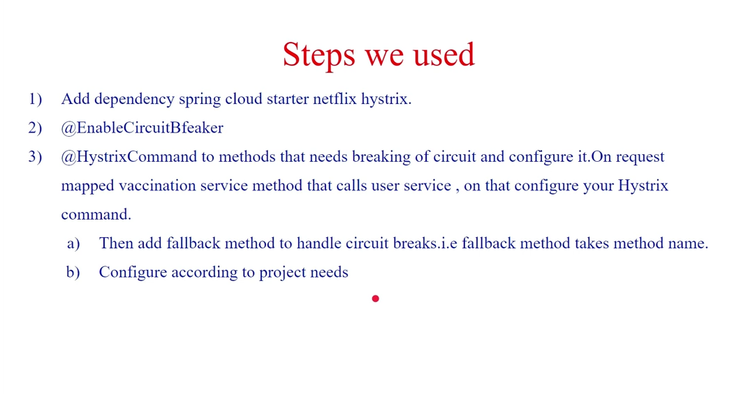

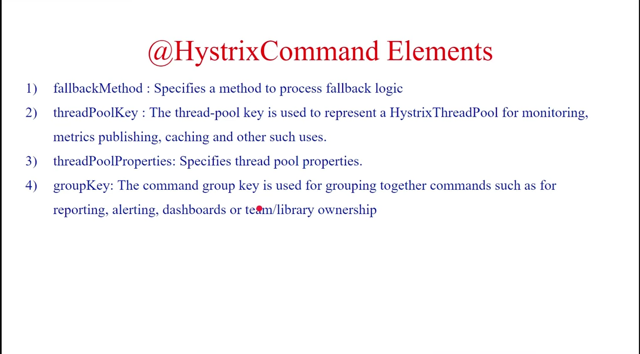

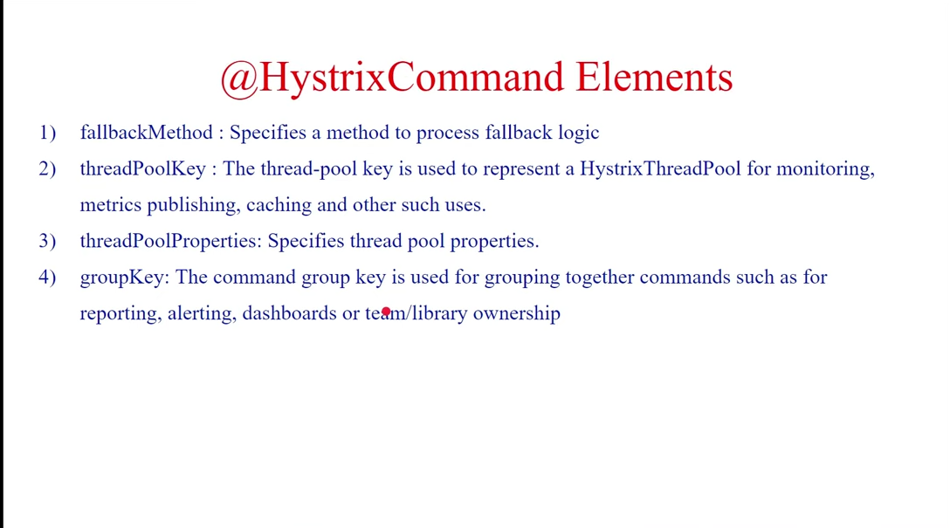

**Advantages:**

1. Circuit-breakers are a great replacement for mechanically operating fuses.

2. Circuit-breakers are highly reliable.

3. Circuit-breakers are more functional.

4. Circuit-breaker can be fixed once, easy to reset and lasts for a long time.